Sort

Cruz Collazo Wendy Paola.

*Seminario de solución de Problemas de Algoritmia.*

**Lineamientos de Evaluación:**

* El reporte está en Formato Google Docs o PDF.
* El reporte sigue las pautas del **Formato de Actividades**.
* El reporte tiene desarrollada todas las pautas del **Formato de Actividades**.
* Se muestra captura de pantalla de las partículas del antes y después de ser ordenadas por id de manera ascendente tanto en el **QPlainTextEdi**t como en el **QTableWidget**.
* Se muestra captura de pantalla de las partículas del antes y después de ser ordenadas por distancia de manera descendente tanto en el **QPlainTextEdi**t como en el **QTableWidget**.
* Se muestra captura de pantalla de las partículas del antes y después de ser ordenadas por velocidad de manera ascendente tanto en el **QPlainTextEdi**t como en el **QTableWidget**.

Desarrollo:

* Datos Antes de Ordenarlos En el QPlainTextEdit

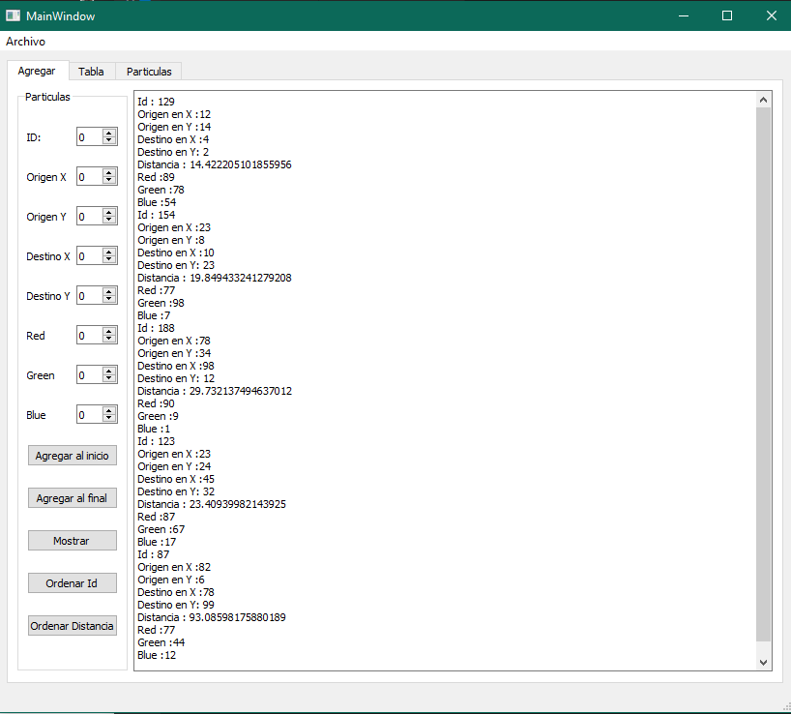

* Datos Después de Ordenarlos por Id en el QPlainTextEdit.

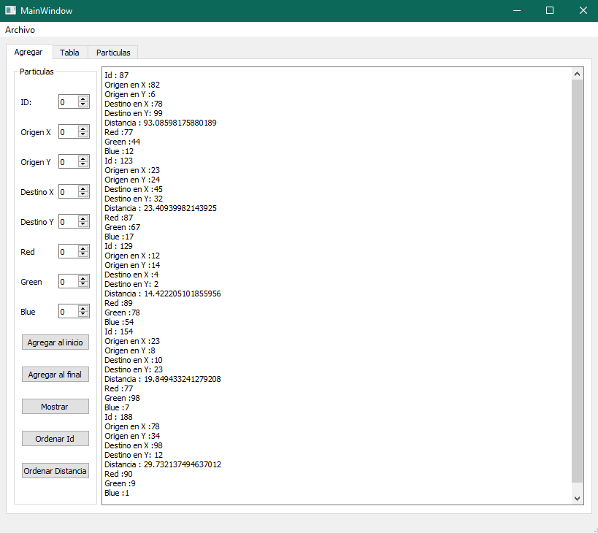

* Datos Después de Ordenarlos por Distancia en el QPlainTextEdit.

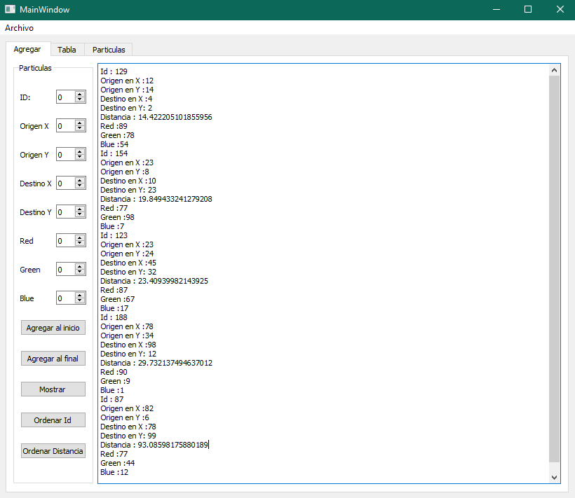

* Datos Antes de Ordenarlos en el QTableWidget.

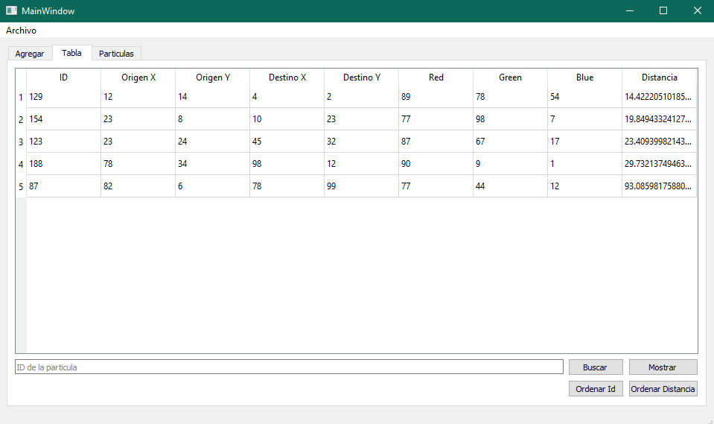

* Datos Después de Ordenarlos por Id en el QTableWidget.

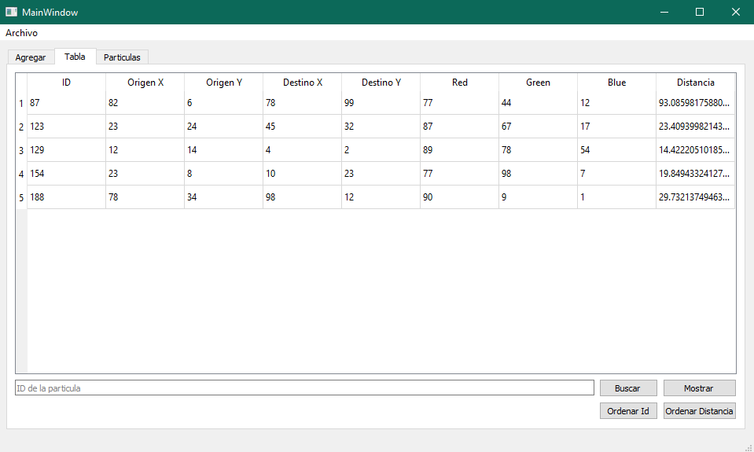

* Datos Después de Ordenarlos por Distancia en el QTableWidget.

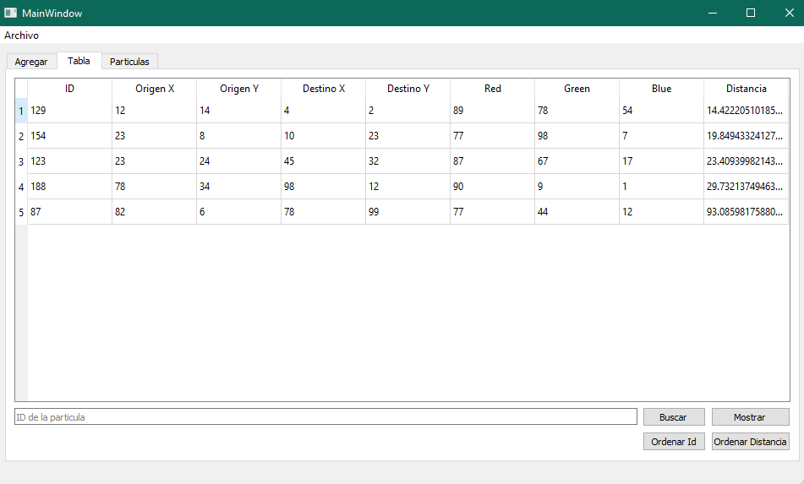

Conclusión:

Para mi esta actividad fue la mas sencilla de las que hemos hecho, es interesante como con un par de líneas de codigo se pueda ver de mejor manera la Información. No tuve complicaciones al momento de hacer la actividad.

Referencias:

* Python- sort() -Michel Davalos Boites.

<https://www.youtube.com/watch?v=0NZajLIy5qQ>

Codigo:

* Administradora.py
* from particula import Particula
* import json
* class Administradora:
* def __init__(self):
* self.__particulas = []
* def agregar_final(self,particula:Particula):
* self.__particulas.append(particula)
* def agregar_inicio(self,particula:Particula):
* self.__particulas.insert(0,particula)
* def mostrar(self):
* for particula in self.__particulas:
* print(particula)
* def __str__(self):
* return "".join(
* str(particula) for particula in self.__particulas
* )
* def __len__(self):
* return (len(self.__particulas))

* def __iter__(self):
* self.cont = 0
* return self
* def __next__(self):
* if self.cont < len(self.__particulas):
* particula = self.__particulas[self.cont]
* self.cont += 1
* return particula
* else:
* raise StopIteration
* def guardar(self,ubiacion):
* try:
* with open(ubiacion,'w') as archivo:
* lista = [particula.to_dict() for particula in self.__particulas]
* json.dump(lista,archivo, indent = 5)
* return
* except:
* return 0
* #json.dump()
* def abrir(self,ubicacion):
* try:
* with open(ubicacion,'r') as archivo:
* lista = json.load(archivo)
* self.__particulas = [Particula(**particula)for particula in lista]
* return 1
* except:
* return 0
* def ordenar_id(self):
* return self.__particulas.sort(key=lambda particula: particula.id)
* def ordenar_distancia(self):
* return self.__particulas.sort(key=lambda particula: particula.distancia)
* Algoritmos.py
* import math
* def distancia_euclidiana(x_1, y_1, x_2, y_2):
* a = (x_2 - x_1)*(x_2 - x_1)
* b = (y_2 - y_1)*(y_2 - y_1)
* c = a + b
* distancia = math.sqrt(c)
* return distancia

* Main.py
* from PySide2.QtWidgets import QApplication
* from mainwindow import MainWindow
* import sys
* app = QApplication()
* window = MainWindow()
* window.show()
* sys.exit(app.exec_())
* Mainwindow.py
* from re import S
* from PySide2.QtWidgets import QMainWindow,QFileDialog,QMessageBox,QTableWidgetItem, QGraphicsScene
* from ui_mainwindow import Ui_MainWindow
* from administradora import Administradora
* from particula import Particula
* from PySide2.QtCore import Slot
* from PySide2.QtGui import QPen, QColor, QTransform
* class MainWindow(QMainWindow):
* def __init__(self):
* super(MainWindow,self).__init__()
* self.administrador = Administradora()
* self.ui = Ui_MainWindow()
* self.ui.setupUi(self)
* self.ui.Agregar_final.clicked.connect(self.agregar_final)
* self.ui.Agregar_Inicio.clicked.connect(self.agregar_inicio)
* self.ui.Mostrar.clicked.connect(self.ver)
* self.ui.actionAbrir.triggered.connect(self.action_abrir_archivo)
* self.ui.actionGuardar.triggered.connect(self.action_guardar_archivo)
* self.ui.view_button.clicked.connect(self.mostrar_tabla)
* self.ui.search_button.clicked.connect(self.buscar_tabla)
* self.ui.dibujar.clicked.connect(self.dibujar)
* self.ui.limpiar.clicked.connect(self.limipiar)
* self.scene = QGraphicsScene()
* self.ui.graphicsView.setScene(self.scene)
* self.ui.ordenar_Id.clicked.connect(self.Ordenar_Id)
* self.ui.ordenar_id2.clicked.connect(self.Ordenar_Id2)
* self.ui.ordenar_distancia.clicked.connect(self.Ordenar_Distancia)
* self.ui.ordenar_distancia2.clicked.connect(self.Ordenar_Distancia2)
* @Slot ()
* def Ordenar_Id(self):
* self.ui.Print.clear()
* self.administrador.ordenar_id()
* self.ui.Print.insertPlainText(str(self.administrador))
* @Slot ()
* def Ordenar_Distancia(self):
* self.ui.Print.clear()
* self.administrador.ordenar_distancia()
* self.ui.Print.insertPlainText(str(self.administrador))
* @Slot ()
* def Ordenar_Id2(self):
* self.ui.table.clear()
* self.administrador.ordenar_id()
* self.ui.table.setColumnCount(9)
* headers = ["ID","Origen X","Origen Y","Destino X","Destino Y","Red","Green","Blue","Distancia"]
* self.ui.table.setHorizontalHeaderLabels(headers)
* self.ui.table.setRowCount(len(self.administrador))
* row = 0
* for particula in self.administrador:
* id_widget = QTableWidgetItem(str(particula.id))
* origenx_widget = QTableWidgetItem(str(particula.origen_x))
* origeny_widget = QTableWidgetItem(str(particula.origen_y))
* destinox_widget = QTableWidgetItem(str(particula.destino_x))
* destinoy_widget = QTableWidgetItem(str(particula.destino_y))
* red_widget = QTableWidgetItem(str(particula.red))
* green_widget = QTableWidgetItem(str(particula.green))
* blue_widget = QTableWidgetItem(str(particula.blue))
* distancia_widget = QTableWidgetItem(str(particula.distancia))
* self.ui.table.setItem(row,0,id_widget)
* self.ui.table.setItem(row,1,origenx_widget)
* self.ui.table.setItem(row,2,origeny_widget)
* self.ui.table.setItem(row,3,destinox_widget)
* self.ui.table.setItem(row,4,destinoy_widget)
* self.ui.table.setItem(row,5,red_widget)
* self.ui.table.setItem(row,6,green_widget)
* self.ui.table.setItem(row,7,blue_widget)
* self.ui.table.setItem(row,8,distancia_widget)
* row += 1
* @Slot ()
* def Ordenar_Distancia2(self):
* self.ui.table.clear()
* self.administrador.ordenar_distancia()
* self.ui.table.setColumnCount(9)
* headers = ["ID","Origen X","Origen Y","Destino X","Destino Y","Red","Green","Blue","Distancia"]
* self.ui.table.setHorizontalHeaderLabels(headers)
* self.ui.table.setRowCount(len(self.administrador))
* row = 0
* for particula in self.administrador:
* id_widget = QTableWidgetItem(str(particula.id))
* origenx_widget = QTableWidgetItem(str(particula.origen_x))
* origeny_widget = QTableWidgetItem(str(particula.origen_y))
* destinox_widget = QTableWidgetItem(str(particula.destino_x))
* destinoy_widget = QTableWidgetItem(str(particula.destino_y))
* red_widget = QTableWidgetItem(str(particula.red))
* green_widget = QTableWidgetItem(str(particula.green))
* blue_widget = QTableWidgetItem(str(particula.blue))
* distancia_widget = QTableWidgetItem(str(particula.distancia))
* self.ui.table.setItem(row,0,id_widget)
* self.ui.table.setItem(row,1,origenx_widget)
* self.ui.table.setItem(row,2,origeny_widget)
* self.ui.table.setItem(row,3,destinox_widget)
* self.ui.table.setItem(row,4,destinoy_widget)
* self.ui.table.setItem(row,5,red_widget)
* self.ui.table.setItem(row,6,green_widget)
* self.ui.table.setItem(row,7,blue_widget)
* self.ui.table.setItem(row,8,distancia_widget)
* row += 1
* @Slot()
* def wheelEvent(self, event):
* if event.delta() > 0:
* self.ui.graphicsView.scale(1.2, 1.2)
* else:
* self.ui.graphicsView.scale(0.8, 0.8)
* @Slot ()
* def dibujar(self):
* pen = QPen()
* pen.setWidth(3)
* for particula in self.administrador:
* origenx = int(particula.origen_x)
* origeny = int(particula.origen_y)
* destinox = int(particula.destino_x)
* destinoy = int(particula.destino_y)
* red = int(particula.red)
* green = int(particula.green)
* blue = int(particula.blue)
* color = QColor(red, green, blue)
* pen.setColor(color)
* self.scene.addEllipse(origenx, origeny, 3, 3, pen)
* self.scene.addEllipse(destinox, destinoy, 3, 3, pen)
* self.scene.addLine(origenx, origeny, destinox, destinoy, pen)
* @Slot()
* def limipiar(self):
* self.scene.clear()
* @Slot()
* def buscar_tabla(self):
* id = self.ui.search_line.text()
* encontrado = False
* for particula in self.administrador:
* if int(id)  ==  particula.id:
* self.ui.table.clear()
* self.ui.table.setRowCount(1)
* headers = ["ID","Origen X","Origen Y","Destino X","Destino Y","Red","Green","Blue","Distancia"]
* self.ui.table.setHorizontalHeaderLabels(headers)
* id_widget = QTableWidgetItem(str(particula.id))
* origenx_widget = QTableWidgetItem(str(particula.origen_x))
* origeny_widget = QTableWidgetItem(str(particula.origen_y))
* destinox_widget = QTableWidgetItem(str(particula.destino_x))
* destinoy_widget = QTableWidgetItem(str(particula.destino_y))
* red_widget = QTableWidgetItem(str(particula.red))
* green_widget = QTableWidgetItem(str(particula.green))
* blue_widget = QTableWidgetItem(str(particula.blue))
* distancia_widget = QTableWidgetItem(str(particula.distancia))
* self.ui.table.setItem(0,0,id_widget)
* self.ui.table.setItem(0,1,origenx_widget)
* self.ui.table.setItem(0,2,origeny_widget)
* self.ui.table.setItem(0,3,destinox_widget)
* self.ui.table.setItem(0,4,destinoy_widget)
* self.ui.table.setItem(0,5,red_widget)
* self.ui.table.setItem(0,6,green_widget)
* self.ui.table.setItem(0,7,blue_widget)
* self.ui.table.setItem(0,8,distancia_widget)
* encontrado = True
* return
* if not encontrado:
* QMessageBox.warning(self,'Atencíon',f'La particula con ID "{id}" no fue encontrado')
* @Slot()
* def mostrar_tabla(self):
* self.ui.table.setColumnCount(9)
* headers = ["ID","Origen X","Origen Y","Destino X","Destino Y","Red","Green","Blue","Distancia"]
* self.ui.table.setHorizontalHeaderLabels(headers)
* self.ui.table.setRowCount(len(self.administrador))
* row = 0
* for particula in self.administrador:
* id_widget = QTableWidgetItem(str(particula.id))
* origenx_widget = QTableWidgetItem(str(particula.origen_x))
* origeny_widget = QTableWidgetItem(str(particula.origen_y))
* destinox_widget = QTableWidgetItem(str(particula.destino_x))
* destinoy_widget = QTableWidgetItem(str(particula.destino_y))
* red_widget = QTableWidgetItem(str(particula.red))
* green_widget = QTableWidgetItem(str(particula.green))
* blue_widget = QTableWidgetItem(str(particula.blue))
* distancia_widget = QTableWidgetItem(str(particula.distancia))
* self.ui.table.setItem(row,0,id_widget)
* self.ui.table.setItem(row,1,origenx_widget)
* self.ui.table.setItem(row,2,origeny_widget)
* self.ui.table.setItem(row,3,destinox_widget)
* self.ui.table.setItem(row,4,destinoy_widget)
* self.ui.table.setItem(row,5,red_widget)
* self.ui.table.setItem(row,6,green_widget)
* self.ui.table.setItem(row,7,blue_widget)
* self.ui.table.setItem(row,8,distancia_widget)
* row += 1
* @Slot()
* def action_abrir_archivo(self):
* ubicacion = QFileDialog.getOpenFileName(self,'Abrir Archivo','.','JSON (*.json)')[0]
* if self.administrador.abrir(ubicacion):
* QMessageBox.information(self,"Exito","Se abrió el archivo de" + ubicacion)
* else:
* QMessageBox.information(self,"Error","No se pudo abrir el archivo de " + ubicacion)

* @Slot()
* def action_guardar_archivo(self):
* ubicacion = QFileDialog.getSaveFileName(self,'Guardar Archivo','.','JSON (*.json)')[0]
* if self.administrador.guardar(ubicacion):
* QMessageBox.information(self,"Exito","Se creó el archivo con exito en " + ubicacion)
* else:
* QMessageBox.information(self,"Error","No se pudo crear el archivo en " + ubicacion)
* @Slot()
* def ver(self):
* self.ui.Print.clear()
* self.ui.Print.insertPlainText(str(self.administrador))
* @Slot()
* def agregar_final(self):
* ID = self.ui.ID_spinBox.value()
* OrigenX = self.ui.OrigenX_spinBox.value()
* OrigenY = self.ui.OrigenY_spinBox.value()
* DestinoX = self.ui.DestinoX_spinBox.value()
* DestinoY = self.ui.DestinoY_spinBox.value()
* Red = self.ui.Red_spinBox.value()
* Green = self.ui.Green_spinBox.value()
* Blue = self.ui.Blue_spinBox.value()
* particula1 = Particula(ID,OrigenX,OrigenY,DestinoX,DestinoY,Red,Green,Blue)
* self.administrador.agregar_final(particula1)
* @Slot()
* def agregar_inicio(self):
* ID = self.ui.ID_spinBox.value()
* OrigenX = self.ui.OrigenX_spinBox.value()
* OrigenY = self.ui.OrigenY_spinBox.value()
* DestinoX = self.ui.DestinoX_spinBox.value()
* DestinoY = self.ui.DestinoY_spinBox.value()
* Red = self.ui.Red_spinBox.value()
* Green = self.ui.Green_spinBox.value()
* Blue = self.ui.Blue_spinBox.value()
* particula1 = Particula(ID,OrigenX,OrigenY,DestinoX,DestinoY,Red,Green,Blue)
* self.administrador.agregar_inicio(particula1)
* Particula.py
* from algoritmos import distancia_euclidiana
* class Particula:
* def __init__(self,id = 0, origen_x = 0, origen_y = 0, destino_x = 0, destino_y=0,red = 0, green = 0, blue = 0):
* self.__id = id
* self.__origen_x = origen_x
* self.__origen_y = origen_y
* self.__destino_x = destino_x
* self.__destino_y = destino_y
* self.__red = red
* self.__green = green
* self.__blue = blue
* self.__distancia = distancia_euclidiana(origen_x,origen_y,destino_x,destino_y)
* def __str__(self):
* return('Id : ' + str(self.__id) + '\n' + 'Origen en X :' + str(self.__origen_x) + '\n' +
* 'Origen en Y :' + str(self.__origen_y) + '\n' + 'Destino en X :' + str(self.__destino_x) + '\n' +
* 'Destino en Y: ' + str(self.__destino_y) + '\n' + 'Distancia : ' + str(self.__distancia) + '\n' +
* 'Red :' + str(self.__red) + '\n' 'Green :' + str(self.__green) + '\n' 'Blue :' + str(self.__blue) + '\n')
* @property
* def id(self):
* return self.__id
* @property
* def origen_x(self):
* return self.__origen_x
* @property
* def origen_y(self):
* return self.__origen_y
* @property
* def destino_x(self):
* return self.__destino_x
* @property
* def destino_y(self):
* return self.__destino_y
* @property
* def red(self):
* return self.__red
* @property
* def green(self):
* return self.__green
* @property
* def blue(self):
* return self.__blue
* @property
* def distancia(self):
* return self.__distancia
* def to_dict(self):
* return {
* "id": self.__id,
* "origen_x": self.__origen_x,
* "origen_y": self.__origen_y,
* "destino_x": self.__destino_x,
* "destino_y": self.__destino_y,
* "red": self.__red,
* "green": self.__green,
* "blue": self.__blue
* }
* Ui_mainwindow.py
* from PySide2.QtCore import *
* from PySide2.QtGui import *
* from PySide2.QtWidgets import *
* class Ui_MainWindow(object):
* def setupUi(self, MainWindow):
* if not MainWindow.objectName():
* MainWindow.setObjectName(u"MainWindow")
* MainWindow.resize(583, 552)
* self.actionAbrir = QAction(MainWindow)
* self.actionAbrir.setObjectName(u"actionAbrir")
* self.actionGuardar = QAction(MainWindow)
* self.actionGuardar.setObjectName(u"actionGuardar")
* self.centralwidget = QWidget(MainWindow)
* self.centralwidget.setObjectName(u"centralwidget")
* self.gridLayout_3 = QGridLayout(self.centralwidget)
* self.gridLayout_3.setObjectName(u"gridLayout_3")
* self.tabWidget = QTabWidget(self.centralwidget)
* self.tabWidget.setObjectName(u"tabWidget")
* self.tab = QWidget()
* self.tab.setObjectName(u"tab")
* self.gridLayout_2 = QGridLayout(self.tab)
* self.gridLayout_2.setObjectName(u"gridLayout_2")
* self.groupBox = QGroupBox(self.tab)
* self.groupBox.setObjectName(u"groupBox")
* self.gridLayout = QGridLayout(self.groupBox)
* self.gridLayout.setObjectName(u"gridLayout")
* self.label_2 = QLabel(self.groupBox)
* self.label_2.setObjectName(u"label_2")
* self.gridLayout.addWidget(self.label_2, 6, 0, 1, 1)
* self.label0 = QLabel(self.groupBox)
* self.label0.setObjectName(u"label0")
* self.gridLayout.addWidget(self.label0, 1, 0, 1, 1)
* self.label_5 = QLabel(self.groupBox)
* self.label_5.setObjectName(u"label_5")
* self.gridLayout.addWidget(self.label_5, 5, 0, 1, 1)
* self.OrigenY_spinBox = QSpinBox(self.groupBox)
* self.OrigenY_spinBox.setObjectName(u"OrigenY_spinBox")
* self.OrigenY_spinBox.setMaximum(999)
* self.gridLayout.addWidget(self.OrigenY_spinBox, 3, 1, 1, 1)
* self.Blue_spinBox = QSpinBox(self.groupBox)
* self.Blue_spinBox.setObjectName(u"Blue_spinBox")
* self.gridLayout.addWidget(self.Blue_spinBox, 8, 1, 1, 1)
* self.label_3 = QLabel(self.groupBox)
* self.label_3.setObjectName(u"label_3")
* self.gridLayout.addWidget(self.label_3, 3, 0, 1, 1)
* self.label_4 = QLabel(self.groupBox)
* self.label_4.setObjectName(u"label_4")
* self.gridLayout.addWidget(self.label_4, 4, 0, 1, 1)
* self.Mostrar = QPushButton(self.groupBox)
* self.Mostrar.setObjectName(u"Mostrar")
* self.gridLayout.addWidget(self.Mostrar, 11, 0, 1, 2)
* self.Red_spinBox = QSpinBox(self.groupBox)
* self.Red_spinBox.setObjectName(u"Red_spinBox")
* self.gridLayout.addWidget(self.Red_spinBox, 6, 1, 1, 1)
* self.DestinoX_spinBox = QSpinBox(self.groupBox)
* self.DestinoX_spinBox.setObjectName(u"DestinoX_spinBox")
* self.DestinoX_spinBox.setMaximum(255)
* self.gridLayout.addWidget(self.DestinoX_spinBox, 4, 1, 1, 1)
* self.Agregar_Inicio = QPushButton(self.groupBox)
* self.Agregar_Inicio.setObjectName(u"Agregar_Inicio")
* self.gridLayout.addWidget(self.Agregar_Inicio, 9, 0, 1, 2)
* self.ordenar_Id = QPushButton(self.groupBox)
* self.ordenar_Id.setObjectName(u"ordenar_Id")
* self.gridLayout.addWidget(self.ordenar_Id, 12, 0, 1, 2)
* self.ID_spinBox = QSpinBox(self.groupBox)
* self.ID_spinBox.setObjectName(u"ID_spinBox")
* self.ID_spinBox.setMaximum(999)
* self.gridLayout.addWidget(self.ID_spinBox, 0, 1, 1, 1)
* self.label = QLabel(self.groupBox)
* self.label.setObjectName(u"label")
* self.gridLayout.addWidget(self.label, 0, 0, 1, 1)
* self.label_8 = QLabel(self.groupBox)
* self.label_8.setObjectName(u"label_8")
* self.gridLayout.addWidget(self.label_8, 8, 0, 1, 1)
* self.Agregar_final = QPushButton(self.groupBox)
* self.Agregar_final.setObjectName(u"Agregar_final")
* self.gridLayout.addWidget(self.Agregar_final, 10, 0, 1, 2)
* self.Green_spinBox = QSpinBox(self.groupBox)
* self.Green_spinBox.setObjectName(u"Green_spinBox")
* self.gridLayout.addWidget(self.Green_spinBox, 7, 1, 1, 1)
* self.label_7 = QLabel(self.groupBox)
* self.label_7.setObjectName(u"label_7")
* self.gridLayout.addWidget(self.label_7, 7, 0, 1, 1)
* self.OrigenX_spinBox = QSpinBox(self.groupBox)
* self.OrigenX_spinBox.setObjectName(u"OrigenX_spinBox")
* self.OrigenX_spinBox.setMaximum(999)
* self.gridLayout.addWidget(self.OrigenX_spinBox, 1, 1, 1, 1)
* self.DestinoY_spinBox = QSpinBox(self.groupBox)
* self.DestinoY_spinBox.setObjectName(u"DestinoY_spinBox")
* self.DestinoY_spinBox.setMaximum(255)
* self.gridLayout.addWidget(self.DestinoY_spinBox, 5, 1, 1, 1)
* self.ordenar_distancia = QPushButton(self.groupBox)
* self.ordenar_distancia.setObjectName(u"ordenar_distancia")
* self.gridLayout.addWidget(self.ordenar_distancia, 13, 0, 1, 2)
* self.gridLayout_2.addWidget(self.groupBox, 0, 0, 1, 1)
* self.Print = QPlainTextEdit(self.tab)
* self.Print.setObjectName(u"Print")
* self.gridLayout_2.addWidget(self.Print, 0, 1, 1, 1)
* self.tabWidget.addTab(self.tab, "")
* self.tab_2 = QWidget()
* self.tab_2.setObjectName(u"tab_2")
* self.gridLayout_4 = QGridLayout(self.tab_2)
* self.gridLayout_4.setObjectName(u"gridLayout_4")
* self.table = QTableWidget(self.tab_2)
* self.table.setObjectName(u"table")
* self.gridLayout_4.addWidget(self.table, 0, 0, 1, 4)
* self.horizontalSpacer = QSpacerItem(40, 20, QSizePolicy.Expanding, QSizePolicy.Minimum)
* self.gridLayout_4.addItem(self.horizontalSpacer, 2, 0, 1, 1)
* self.view_button = QPushButton(self.tab_2)
* self.view_button.setObjectName(u"view_button")
* self.gridLayout_4.addWidget(self.view_button, 1, 3, 1, 1)
* self.search_button = QPushButton(self.tab_2)
* self.search_button.setObjectName(u"search_button")
* self.gridLayout_4.addWidget(self.search_button, 1, 2, 1, 1)
* self.search_line = QLineEdit(self.tab_2)
* self.search_line.setObjectName(u"search_line")
* self.gridLayout_4.addWidget(self.search_line, 1, 0, 1, 2)
* self.ordenar_distancia2 = QPushButton(self.tab_2)
* self.ordenar_distancia2.setObjectName(u"ordenar_distancia2")
* self.gridLayout_4.addWidget(self.ordenar_distancia2, 2, 3, 1, 1)
* self.ordenar_id2 = QPushButton(self.tab_2)
* self.ordenar_id2.setObjectName(u"ordenar_id2")
* self.gridLayout_4.addWidget(self.ordenar_id2, 2, 2, 1, 1)
* self.tabWidget.addTab(self.tab_2, "")
* self.tab_3 = QWidget()
* self.tab_3.setObjectName(u"tab_3")
* self.gridLayout_5 = QGridLayout(self.tab_3)
* self.gridLayout_5.setObjectName(u"gridLayout_5")
* self.dibujar = QPushButton(self.tab_3)
* self.dibujar.setObjectName(u"dibujar")
* self.gridLayout_5.addWidget(self.dibujar, 1, 0, 1, 1)
* self.limpiar = QPushButton(self.tab_3)
* self.limpiar.setObjectName(u"limpiar")
* self.gridLayout_5.addWidget(self.limpiar, 1, 1, 1, 1)
* self.graphicsView = QGraphicsView(self.tab_3)
* self.graphicsView.setObjectName(u"graphicsView")
* self.gridLayout_5.addWidget(self.graphicsView, 0, 0, 1, 2)
* self.tabWidget.addTab(self.tab_3, "")
* self.gridLayout_3.addWidget(self.tabWidget, 0, 0, 1, 1)
* MainWindow.setCentralWidget(self.centralwidget)
* self.menubar = QMenuBar(MainWindow)
* self.menubar.setObjectName(u"menubar")
* self.menubar.setGeometry(QRect(0, 0, 583, 21))
* self.menuArchivo = QMenu(self.menubar)
* self.menuArchivo.setObjectName(u"menuArchivo")
* MainWindow.setMenuBar(self.menubar)
* self.statusbar = QStatusBar(MainWindow)
* self.statusbar.setObjectName(u"statusbar")
* MainWindow.setStatusBar(self.statusbar)
* self.menubar.addAction(self.menuArchivo.menuAction())
* self.menuArchivo.addAction(self.actionAbrir)
* self.menuArchivo.addAction(self.actionGuardar)
* self.retranslateUi(MainWindow)
* self.tabWidget.setCurrentIndex(1)
* QMetaObject.connectSlotsByName(MainWindow)
* # setupUi
* def retranslateUi(self, MainWindow):
* MainWindow.setWindowTitle(QCoreApplication.translate("MainWindow", u"MainWindow", None))
* self.actionAbrir.setText(QCoreApplication.translate("MainWindow", u"Abrir", None))
* #if QT_CONFIG(shortcut)
* self.actionAbrir.setShortcut(QCoreApplication.translate("MainWindow", u"Ctrl+O", None))
* #endif // QT_CONFIG(shortcut)
* self.actionGuardar.setText(QCoreApplication.translate("MainWindow", u"Guardar", None))
* #if QT_CONFIG(shortcut)
* self.actionGuardar.setShortcut(QCoreApplication.translate("MainWindow", u"Ctrl+D", None))
* #endif // QT_CONFIG(shortcut)
* self.groupBox.setTitle(QCoreApplication.translate("MainWindow", u"Particulas", None))
* self.label_2.setText(QCoreApplication.translate("MainWindow", u"Red", None))
* self.label0.setText(QCoreApplication.translate("MainWindow", u"Origen X", None))
* self.label_5.setText(QCoreApplication.translate("MainWindow", u"Destino Y", None))
* self.label_3.setText(QCoreApplication.translate("MainWindow", u"Origen Y", None))
* self.label_4.setText(QCoreApplication.translate("MainWindow", u"Destino X", None))
* self.Mostrar.setText(QCoreApplication.translate("MainWindow", u"Mostrar", None))
* self.Agregar_Inicio.setText(QCoreApplication.translate("MainWindow", u"Agregar al inicio", None))
* self.ordenar_Id.setText(QCoreApplication.translate("MainWindow", u"Ordenar Id", None))
* self.label.setText(QCoreApplication.translate("MainWindow", u"ID:", None))
* self.label_8.setText(QCoreApplication.translate("MainWindow", u"Blue", None))
* self.Agregar_final.setText(QCoreApplication.translate("MainWindow", u"Agregar al final", None))
* self.label_7.setText(QCoreApplication.translate("MainWindow", u"Green", None))
* self.ordenar_distancia.setText(QCoreApplication.translate("MainWindow", u"Ordenar Distancia", None))
* self.tabWidget.setTabText(self.tabWidget.indexOf(self.tab), QCoreApplication.translate("MainWindow", u"Agregar", None))
* self.view_button.setText(QCoreApplication.translate("MainWindow", u"Mostrar", None))
* self.search_button.setText(QCoreApplication.translate("MainWindow", u"Buscar", None))
* self.search_line.setPlaceholderText(QCoreApplication.translate("MainWindow", u"ID de la particula", None))
* self.ordenar_distancia2.setText(QCoreApplication.translate("MainWindow", u"Ordenar Distancia", None))
* self.ordenar_id2.setText(QCoreApplication.translate("MainWindow", u"Ordenar Id", None))
* self.tabWidget.setTabText(self.tabWidget.indexOf(self.tab_2), QCoreApplication.translate("MainWindow", u"Tabla", None))
* self.dibujar.setText(QCoreApplication.translate("MainWindow", u"Dibujar", None))
* self.limpiar.setText(QCoreApplication.translate("MainWindow", u"Limpiar", None))
* self.tabWidget.setTabText(self.tabWidget.indexOf(self.tab_3), QCoreApplication.translate("MainWindow", u"Particulas", None))
* self.menuArchivo.setTitle(QCoreApplication.translate("MainWindow", u"Archivo", None))
* # retranslateUi